# Supplementary

Table S1: Search strings used on WoS on 26-08-2019. The first two columns were combined with an AND-statement, the different values within the columns with an OR-statement. The last column gives the refinements used for Web of Science Categories. Taxa that did not give any extra results were Mantodea, Blattodea, Isoptera, Mallophaga, Neuropt*, Mecopt*, Thysanopt*, Psocopt*, Anoplura, Isopoda, Diplopoda, Chilopoda, Megalopt*.

|  |  |  |
| --- | --- | --- |
| kind of tag (OR) | Taxa (OR) | WoS Categories |
| radio tag* | insect | Ecology |
| radio transmitt* | insects | Zoology |
| radio telemetry | arthropod* | Entomology |
| telemetry | invertebrate* | Biodiversity conservation |
| RFID | Coleopt* | Multidisciplinary sciences |
| PIT tag | Hymenopt* | Biology |
| harmonic radar | Hemipt* | Environmental sciences |
|  | Arachnida | Behavioural sciences |
|  | Lepidopt* | Physiology |
|  | Orthopt* | Evolutionary biology |
|  | Trichopt* | Forestry |
|  | Dipt* |  |
|  | Odonata |  |
|  | Ephemeropt* |  |
|  | Plecopt* |  |

Table S2: Results of the statistical analysis of the impact of an RFID tag on *Bembix rostrata* behaviour(Box 1 main text). The response variable is the amount of time a certain behaviour was recorded (out of 25 observations). Only 3 types of behaviour were used for the analysis as 3 others (washing, biting, digging) were rarely recorded for all individuals. The 3rd covariate indicates the body measure that was used in the model: wing loading (WL) or intertegular distance (ITD), which is a proxy for mass. If BA is significant, there is a treatment effect. A significant BA:CI-interaction indicates a tag effect. A significant three-way interaction indicates a difference in tag effect according to the body measurement. Significant and near-significant terms are in bold. All terms were tested with the likelihood ratio tests following a χ² distribution with 8 degrees of freedom.

|  |  |  |  |  |
| --- | --- | --- | --- | --- |
| Response | 3rd covariate | Term | Chisq | p-value |
| Resting | WL | BA | 96.565 | < 2.2e-16 |
|  |  | CI | 0.05 | 0.816 |
|  |  | WL | 0.071 | 0.789 |
|  |  | **BA:CI** | **3.583** | **0.059** |
|  |  | **BA:WL** | **7.759** | **0.006** |
|  |  | CI:WL | 0.249 | 0.618 |
|  |  | **BA:CI:WL** | **18.5841** | **1.626e-05** |
| Resting | ITD | **BA** | **94.775** | **< 2e-16** |
|  |  | CI | 0.070 | 0.791 |
|  |  | ITD | 1.980 | 0.159 |
|  |  | **BA:CI** | **3.468** | **0.063** |
|  |  | BA:ITD | 0.297 | 0.586 |
|  |  | CI:ITD | 0.016 | 0.901 |
|  |  | BA:CI:ITD | 2.584 | 0.108 |
| Flying | WL | **BA** | **12.941** | **0.0003** |
|  |  | **CI** | **4.313** | **0.038** |
|  |  | WL | 0.135 | 0.714 |
|  |  | **BA:CI** | **5.819** | **0.016** |
|  |  | BA:WL | 0.076 | 0.783 |
|  |  | **CI:WL** | **3.641** | **0.056** |
|  |  | **BA:CI:WL** | **3.558** | **0.059** |
| Flying | ITD | **BA** | **13.678** | **0.0002** |
|  |  | **CI** | **3.807** | **0.051** |
|  |  | ITD | 2.428 | 0.119 |
|  |  | **BA:CI** | **5.230** | **0.022** |
|  |  | BA:ITD | 1.646 | 0.120 |
|  |  | CI:ITD | 0.745 | 0.388 |
|  |  | BA:CI:ITD | 0.527 | 0.468 |
| Crawling | WL | **BA** | **61.478** | **4.478e-15** |
|  |  | CI | 0.015 | 0.903 |
|  |  | WL | 0.024 | 0.878 |
|  |  | BA:CI | 0.188 | 0.664 |
|  |  | BA:WL | 0.802 | 0.370 |
|  |  | CI:WL | 0.325 | 0.569 |
|  |  | **BA:CI:WL** | **3.656** | **0.059** |
| Crawling | ITD | **BA** | **59.912** | **9.917e-15** |
|  |  | CI | 0.018 | 0.893 |
|  |  | **ITD** | **6.89** | **0.009** |
|  |  | BA:CI | 0.197 | 0.657 |
|  |  | BA:ITD | 0.0003 | 0.986 |
|  |  | CI:ITD | 1.898 | 0.168 |
|  |  | BA:CI:ITD | 0.004 | 0.953 |

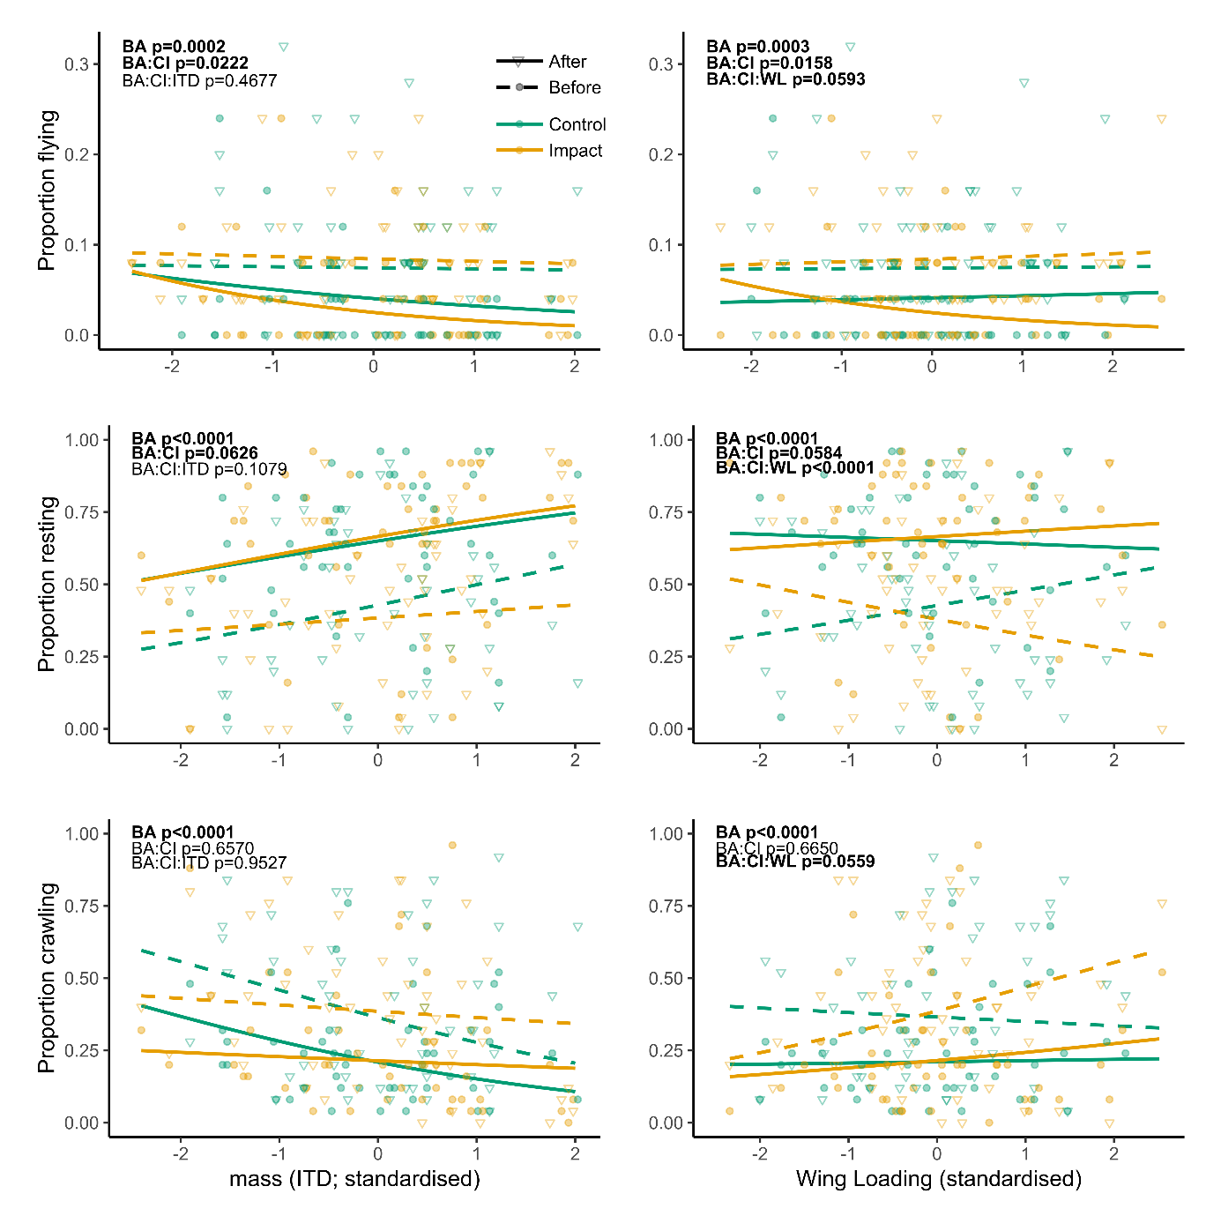

Figure S1: Impact of tags on proportions of three behaviours: flying, resting and crawling. Lines are predictions from the statistical models, points (before) and triangles (after) represent raw data. Solid lines: after, dashed lines: before. Green: control, orange: impact. Time effect (before-after) is significant for all panels. The effect of the tag (interaction BA:CI) is significant for flying (upper two panels) and shows a trend (p=±0.06) for resting (middle two panels). The 3-way interaction is significant (or shows a trend p=±0.06) for the models with wing loading (right panels).